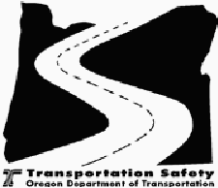
OREGON DEPARTMENT OF TRANSPORTATION
Transportation Safety Division
On-Site Mid-Year Report
Financial records review:
Recommendations for current grant:
Recommendations for continuation:
Project No.:
Agency:
Project Director:
TSD Project Manager:
Date of Visit:
Date of Report:
Project Name:
Project Status:

Page 1 of 2

Report on Objectives:
Findings
Objectives
1.

2.

3.

4.

Equipment Verification:
Serial No.
Date Verified
Verified By
Comments
Verify Until:
Location:
Page 2 of 2

