Iowa Governor’s Traffic Safety Bureau

Program Selection Guidelines
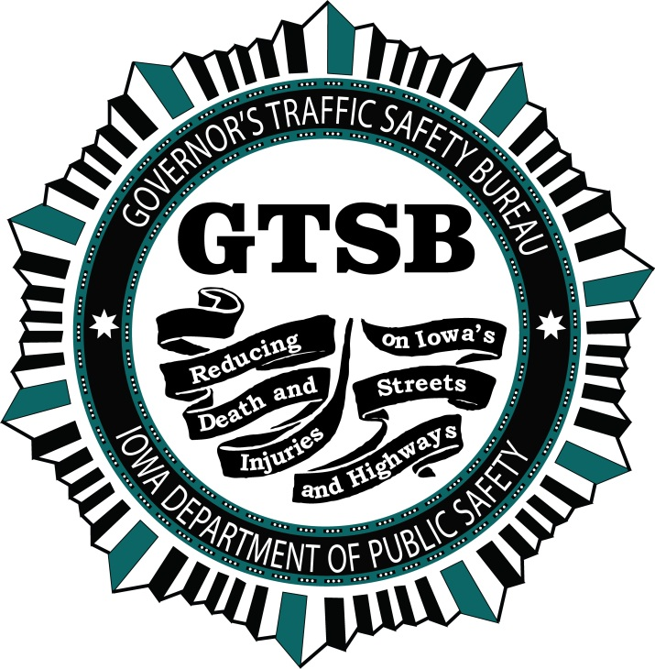

May 2015

Program Evaluator
By January 15th of each year, a new Problem Identification Analysis is completed to determine the comparative severity of traffic safety problems throughout Iowa’s 99 counties. The GTSB’s Program Evaluator is responsible for this function. Results of the problem identification are used by the Governor’s Traffic Safety Bureau to determine which areas of the state have the greatest traffic safety problems and are, therefore, eligible for federal traffic safety funding.
Quantifiable measures of serious traffic incidents are used for the analysis. The Administrative Code of the State of Iowa (661 IAC 20.4(1)) specifies the inclusion of fatal crashes, personal injury crashes, serious personal injury crashes, alcohol-related fatal crashes, alcohol-related personal injury crashes by county, vehicle miles traveled, serious traffic offenses, fatal and injury crashes involving motorcycles, fatal and injury crashes involving pedestrians and bicycles in the problem identification analysis for federally funded Section 402 highway safety programs. The most recent three years of state data are utilized for the analysis and the crash data source is the Iowa Department of Transportation.
For evaluation purposes, each of the nine data element identified in the Administrative Code are given equal weight and there is no particular emphasis on the individual element; and therefore, equal consideration of each element has been adopted. Each county is ranked with the other counties in the nine identified areas from the highest number of occurrences to the lowest. After all categories have been analyzed, the problem rankings of each individual county are averaged and compared providing an overall composite ranking for each of the nine specified areas. To manage Section 402 funding, Iowa limits eligibility to agencies within counties identified by the composite ranking as the “Top 22” most problematic counties. Within these counties, agencies with countywide jurisdiction and cities with a population of at least 5,000 are eligible for Section 402 funding.
Iowa further utilizes the problem identification process to address alcohol-impairment. Moving Ahead for Progress in the 21st Century (MAP-21) Section 405d legislation provides funding for alcohol-related traffic issues. Section 405d funds are available to agencies in counties which have the highest incidence of alcohol-impaired fatalities, alcohol-impaired personal injuries and OWI revocations. To manage Section 405d funding, Iowa limits eligibility to agencies within counties ranked 1 – 40 in regard to alcohol-impairment. All agencies in Iowa’s Top 22 counties are eligible for Section 405d funding as well as all Top 40 agencies with countywide jurisdiction. Agencies with citywide jurisdictions in counties ranked 23-40 are eligible only if their city has a population of 5,000 or more.
The policy for limiting funding to agencies within the Top 22 and Top 40 counties is an internal GTSB policy and can be addressed as needed based on data and/or funding levels.
Applications for Section 402 State and Community Highway Safety Funds and Section 405d Impaired Driving Countermeasures Funds are due to the Bureau before March 1st of each year to be considered for funding in the next fiscal year which begins October 1st.

Grants Administrator
Section 402 and 405d
Once the Problem Identification Analysis is completed, eligible Iowa agencies are identified for notification of funding eligibility. Agencies eligible for Section 402 funding are provided guidelines for funding proposals and an application form to complete. Because Section 405d applications are completed on-line, eligible agencies are provided proposal guidelines and instructions on the web grant system with details on how to complete the on-line application.
The GTSB Grant Administrator is responsible for sorting the database of Iowa agencies by:
- Top 22 counties and cities of 5,000+ or countywide jurisdiction (eligible for 402)
- Top 22 counties and cities under 5,000 (eligible for 405d),
- Top 23-40 counties and cities of 5,000+ (eligible for 405d).
The above agencies are further sorted by those with a current 402 or 405d grant and those that do not. Current grantees that qualify for 402 automatically also qualify for 405d. They receive a letter indicating that their current grant will expire on September 30, that they are eligible for 402 or 405d funding and the guidelines, instructions and forms they need to apply.
Current grantees that qualify for 405d receive a letter indicating that their current grant will expire on September 30, that they are eligible for 405d funding and the guidelines, instructions and web grant information they need to apply.
Agencies without a current grant that qualify for 402 and 405d receive a separate letter explaining the highway safety program(s) they qualify for and the appropriate guidelines, instructions and forms.
All GTSB funding applications/proposals must include: 1) a Problem Statement/Objective that describes the highway safety problem(s) to be addressed; 2) the Proposed Activities and/or Services to be provided that will positively impact the problem; 3) Performance Measures to assess the program’s success in attaining its objectives (quantifiable if possible); and 4) a Budget including the various program elements (personal services, commodities, equipment, contractual services) to be funding and the corresponding funding amount being requested for each item as well as the total requested amount of funding.
Section 405c and 405f
In addition to the Section 402 and 405d eligible agencies, funding notification, application forms and instructions for Section 405c State Traffic Safety Information Systems and 405f Motorcycle Safety are sent out to appropriate agencies with statewide influence.
State agencies that are members of the Statewide Traffic Records Coordinating Committee (STRCC) receive notification, instructions and application forms for Section 405c funding and the Department of Transportation agency responsible for statewide motorcycle training receives notification regarding Section405f funding.
Media Grants
Current media grantees are notified to submit a proposal for the new program year. These agencies have a statewide audience and have demonstrated an ability and interest in raising public awareness of traffic safety issues. Media agencies do not have a set form to complete but, their proposal must include: 1) a Problem Statement/Objective describing the highway safety issues to be addressed; 2) Proposed Activities/Services they will provide to effectively reach Iowans to impact driver behavior; 3) Performance Measures of their audience reach/ exposure, and 4) a Budget/amount needed to perform their proposed activities/services. They must also provide an estimate of the amount and value of earned media they can produce.
Continuation Grants
On-going grants include those for agencies that provide training or research such as the Iowa Law Enforcement Academy, the Prosecuting Attorneys Training Council, Creative Visions, Blank Children’s Hospital, the State Court Administrator’s Office, Unity Point, the University of Iowa’s Injury Prevention Research Center, and the Iowa State University Behavioral Research Center. In addition to research and training grants there is an additional grant that is on-going in six-year cycles. This grant is with the GTSB’s designated advertising agency. Ad agencies must apply via the Iowa Department of Administration’s Request for Proposal process and the agency is selected through a detailed and rigorous and evaluation and selection process. If the Bureau is happy with the agency’s services, they may continue working with them for six years. At that time, another RFP process must be undertaken.
Application Distribution and Summaries
The Grants Administrator provides a copy of each funding application to the appropriate GTSB Program Administrator based on the grant type or area of the state in which the applicant is located and the PA is assigned to.
The Grand Administrator also compiles a summary of all the applications by type (402/405d, 405c/405f) noting the agency, the assigned PA, the total amount requested and the various budget elements being requested by quantity and dollar amount. For web grant applications, this information is taken from the web system. For other applications, the data is compiled manually. These summaries are then provided to the PAs, the Financial Manager and the Bureau Chief.
The summaries are used by the Financial Manager to determine how much money is being requested in each funding source. This information is vital in determining whether an overall funding reduction must be made for any or all of the funding sources.
The information is also used during the final funding decision process to help make funding determination. At that time it is updated to show what funding elements and amounts are approved. The updated database is utilized during the entire program year by both the Grants Administrator and the Financial Manager.
Program Administrator
As Program Administrators receive copies of the proposals submitted for their area, they review them to ensure the applications are complete and appropriate for the highway safety program. If information is missing or there are any questions that need to be answered, the PA contacts the agency to ascertain the needed information. That information is added to the original application and all copies. When necessary, it is also added to the GA’s proposal summary.
PAs review all applications and complete a risk assessment ranking agencies as Low, Medium or High-Risk. New agencies cannot be ranked as Low Risk. If the applicant is a current or prior grantee, past performance is analyzed for completeness/timeliness of reports and claims, no negative findings or unresolved problems, the level at which program objectives were met, public awareness including any earned media, and the overall success of past and/or current grant(s). The PA also determines the percent of prior funds utilized, previous equipment purchases, and the size of the organization. Further, PAs look at whether the agency contact is new to the traffic safety program and may need extra guidance. Information on whether the applicant agency has had any audit finding is provided by the Financial Manager. With all of this information, PAs determine whether the proposed project should be funded and if the funding amount requested is appropriate or if the requested amount should be reduced. A high risk agency will receive additional monitoring and review of their high risk status.
Program Selections
By mid-March, all funding proposals are reviewed by the PAs, the Financial Manager and the Bureau Chief. The PA provides insights into which proposals they deem as worthy and what funding level is appropriate. The Financial Manager provides budget considerations and details on applicants’ prior funded equipment. With this information and input, the Bureau Chief makes the final funding decisions. The Proposal Summaries are updated at this time.
Once budget decisions are made, PAs notify the applicants if they will be awarded a grant and what aspects of the application were approved. If, after deliberations with the applicants, anything in the approved overall budget changes, the Bureau Chief, Grants Administrator and Financial Manager are informed and the Proposal Summaries are updated.
Grants Administrator
sTEP Applications
By mid-March, the same procedure for Section 405d funding is used to create and post a new Funding Opportunity for sTEP. All Iowa law enforcement agencies not slated to receive other GTSB funding are notified of their eligibility for a sTEP grant. Agencies receive an overview of the sTEP program, information on how to register for the on-line system and instructions on how to complete an application. The deadline for sTEP applications is April 30th. Unlike, other funding sources, all sTEP applications are managed by one Program Administrator. Copies of the applications are provided to the sTEP Coordinator (PA) and the Financial Manager.
The Grants Administrator then compiles a listing of the agencies requesting sTEP funding using information from the on-line system. The list includes the Agency Name, Address, Program Manager, Phone/Fax numbers, as well as each budget item requested and the corresponding amount(s). This listing is provided to the sTEP Coordinator and the Financial Manager.
Program Administrator
The sTEP Coordinator reviews all applications to ensure completeness and suitability for the highway safety program. If information is missing or there are any questions, the PA contacts the agency to and gets the needed information. If needed, that information is added to the original application and to the GA’s proposal summary listing.
The sTEP Coordinator reviews all applications and completes a risk assessment ranking agencies as Low, Medium or High-Risk. New agencies cannot be ranked as Low Risk. If the applicant is a current or prior grantee, past performance is analyzed for completeness/timeliness of reports and claims, no negative findings or unresolved problems, level that program objectives were met, public awareness done, as well as the overall success of the past and current grant(s). The percent of prior funds utilized, previous equipment purchases, and the size of the organization are determined. The sTEP Coordinator also looks at whether the agency contact is new to the traffic safety program and may need extra guidance. Information on whether the applicant agency has had any audit finding is provided by the Financial Manager. With all of this information, sTEP Coordinator determines whether the proposed project should be funded and if the funding amount requested is appropriate or if the requested amount should be reduced. A high risk agency will receive additional monitoring and review of their high risk status.
Program Selections
By mid-May, all sTEP applications are then jointly reviewed by the sTEP Coordinator, the Financial Manager and the Bureau Chief. The sTEP Coordinator provides insights into which proposals are suitable for the program and what funding level is appropriate. The Financial Manager provides budget considerations and details on applicants’ prior funded equipment. With this information and input, the Bureau Chief makes the final funding decisions. The Proposal Summary is updated at this time.
Once budget decisions are made, the GA changes the status of the applications in the on-line system to Approved. This generates an email to the applicants notifying them of the application approval. If, after deliberations with the applicants, anything in the approved overall budget changes, the Bureau Chief, Grants Administrator and Financial Manager are informed and the Proposal Summaries are updated.
The Grants Administrator utilizes the Proposal Summaries and Applications for each funding source to generate a draft contract for each approved agency. All contracts begin on October 1st with the exception of sTEP which begins November 1st. Each draft contract is approved by the PA, the Program Evaluator, the Financial Manager and the Bureau Chief. The Bureau Chief signs two copies of the finalized contracts and they are then sent to the Grantees for signing.
Risk Assessment – Funding Proposal Review PE = Public Entity
Agency Name: ________________________________________________________________ Agency Type: City PE, County PE, State PE, (Law Enforcement/University/Health), 501(c)3 Non-profit
Funds applied for: 402, 405b, 405c, 405d, 405f, 402 sTEP; Requested Amount $____________
Size of the organization/jurisdiction: _______________________________________________
Is the applicant a prior or current grantee? Yes ___ No ___. If yes, provide most recent grant:
Contract Number: _________________________, Contract Dollar Amount $____________
Submitted timely reports? Yes ____ No _____, details _________________________________
Timely/accurate claims? Yes ____ No _____, details __________________________________
Any negative findings during a site visit(s)? Yes ____ No _____, details ____________________
______________________________________________________________________________
Has the agency had any audit finding relating to GTSB funds? Yes _____, No ______, details:
______________________________________________________________________________
Has agency been suspended or disbarred? Check at: https://www.sam.gov/portal/SAM/##11
Yes ____, No ____, details ________________________________________________________
Any unresolved problem(s)? Yes ____ No _____, details _______________________________
Public awareness efforts? Yes ____ No _____, Earned media? __________________________
Level at which program objectives were met: ________________________________________
______________________________________________________________________________
Overall success of the prior/current grant: __________________________________________
______________________________________________________________________________
Percent of prior funds utilized: _____; If not 100%, detail: ______________________________
GTSB-funded equipment purchased in the last 5 years (attach sheet or list): _________________
______________________________________________________________________________
Does agency have a new GTSB contact? Yes ___ No ___. Is guidance needed? Yes ___ No ___
Is the amount requested more or less than previous grant? Yes ____ No ____, If yes, detail:
______________________________________________________________________________

Is the agency’s proposal recommended for funding? Yes ____ at $______________, No _____

Overall Risk: Low Risk ___; Medium Risk ___; High Risk ___

PA Signature ________________________________ Date ___________________________

